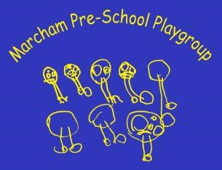
Prospectus
2024

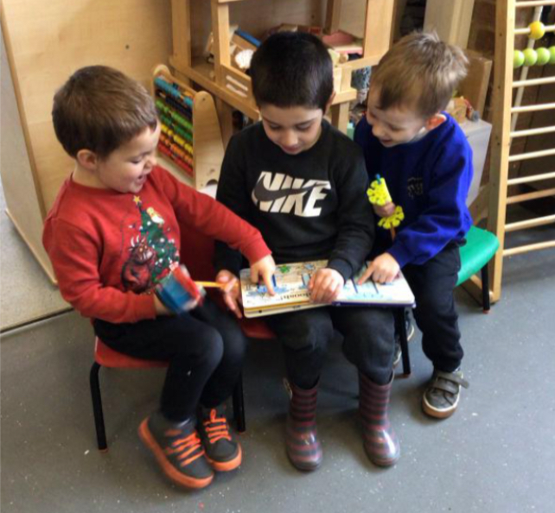
Our Prospectus aims to provide you with the general information about Marcham Pre-school, giving you a view of how our sessions run and the principles and ethos of the pre-school.

We can offer a visit to the setting once the session has finished (3pm), to allow staff to focus on the children’s needs during the day. We can also provide a ‘virtual tour’ aimed at either parents or children.

Please contact Marcham Pre-school on 01865 392101 or email
marcham-preschool@hotmail.co.uk to join our waiting list and request a place.

If you have any questions or if there is something we have not covered, please ask or visit our website at www.marcham-preschool.weebly.com

Our Aims, Values and Principles
Marcham Pre-school provides a relaxed and friendly setting in which young children can play and learn. It is widely recognised that children learn best when they feel happy, secure and are suitably challenged and we aim to provide this through a play-based curriculum with both child and adult -initiated activities and exploration.

We provide an environment where children can learn through their play and while we offer adult-led activities and group times the focus is still on play and discovery so the children can learn at their own pace. Staff are well qualified and experienced and will support the children through their interactions, provision of challenge and by facilitating additional areas to explore.

Within our practice we regularly observe each child and note their achievements and current interests. This information is used to guide us when planning future activities to ensure that each child has the opportunity to experience a variety of areas aimed at their individual level and to further their holistic development.

Children are not made to take part in any activity they do not want to do, but gentle encouragement may be given to help each child to diversify and try new things.

“Our vision is to provide an exciting, friendly, engaging and interesting environment for your child to learn, grow and excel in their Early Years. We aim for our experiences to be BIGGER, to be MESSIER and to be NOISIER than ever before!”
We are passionate about outdoor play, messy and sensory experiences as well as allowing each child to progress and learn at their own pace and in relation to their personal areas of interest.

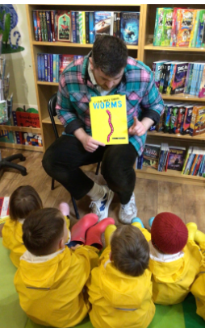
We have many opportunities for the children to experience new and interesting things… from visitors to outings and animal encounters! | We regularly hold ‘Breakfast sessions’ where the children (including older siblings) join us for breakfast at pre-school! This is a fundraising event and a popular addition to our calendar.

Ofsted
Marcham Pre-school is regulated by Ofsted (Office for Standards in Education) who undertake regular inspections. During our last inspection (June 2023) the Inspector’s findings were that all areas were “GOOD”. Our full report can be accessed free at www.ofsted.gov.uk reference EY364409), or you may obtain a copy by contacting us, or visiting our website at
www.marcham-preschool.weebly.com

Comments from our latest Ofsted Report

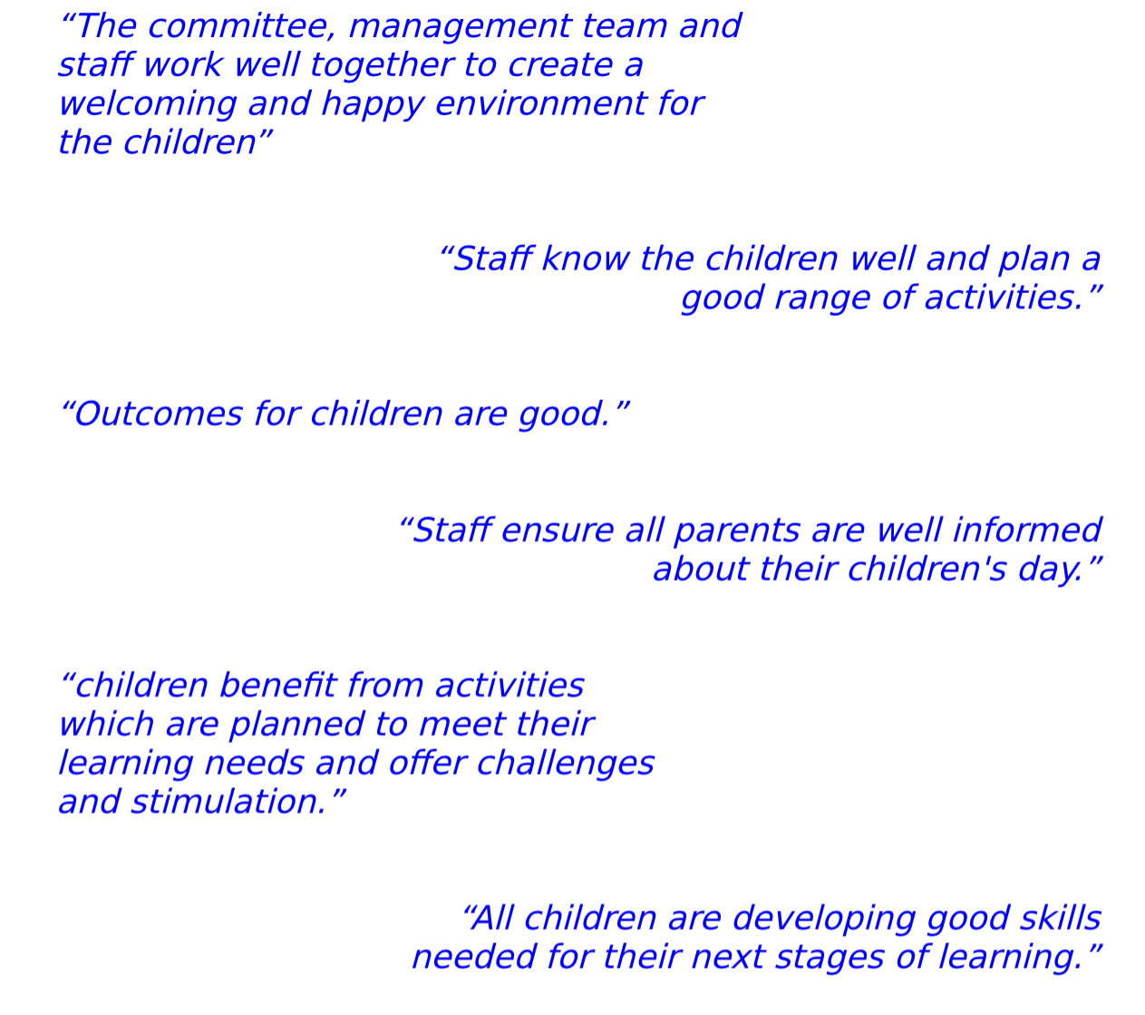

General Information
The Pre-school meets Monday to Friday throughout the school term for the following sessions:

Morning (8:45am -12:00pm) | Charged as 3 hours – or 3 funded hours.
Morning + Lunch (8:45am -1:00pm) | Charged as 4 hours – or 4 funded hours.
Full day (8.45am – 3:00pm) | Charged as 6 hours – or 6 funded hours.

Children are eligible to attend at 2 years old and can continue until they start school. Our main intake is September of each year although subject to availability we will admit children throughout the year in accordance with our admissions policy.

We are members of the Early Years Alliance which ensures we are kept up to date with new initiatives and training. Our Pre-school is managed by a committee of volunteers, which is elected annually by all parents and carers. Marcham Pre-school is a registered charity (number 1062332) and our fees are kept to the minimum necessary to cover wages, heating, electricity and insurance and they are reviewed on an annual basis. Fund-raising is a vital aspect of the committee’s work as well as providing for all the consumables and equipment.

Staff
We employ 5 members of staff, and our highly experienced team is headed by an Early Years Teacher and Senior Practitioner. All staff members hold a professional Early Years qualification to a minimum of level 3 and undertake regular training to continue their own professional development. We ensure each member of staff regularly renews their training and knowledge of paediatric first Aid, safeguarding and food hygiene practices.
Pre-school staff are deployed both inside and outside during the pre-school day and we operate a ‘free-flow’ policy allowing children to play in all areas throughout our sessions. We meet the statutory staff:child ratio as a minimum and often operate at a higher ratio to ensure that the children’s needs are met.
Some examples of other training completed are: -
Identifying ASD in Early Years, supporting communication and language needs, supporting children learning English as an additional language, exploring outside, bringing maths to the outdoors, supporting children’s well-being and self-regulation, working with 2-year-olds.

What the Parents say…
“Our son has learnt so much from the wide range of fun, educational, child-led experiences on offer at pre-school. He adores the opportunities to get messy and do all the squidgy, gooey, dirty things that he's not allowed to do at home! We love the great communications from staff who really care about the children as individuals and know what they need to do next to develop and grow.” – Mrs F

“Our two boys always love coming to Marcham Pre-school and have made so much progress due to the incredible care and dedication of the staff” – Mr & Mrs E

The Committee
Whilst the Early Years Teacher has responsibility for the day-to-day running of the Pre-school, the committee (made up of parents and carers) are responsible for the management and administration of the Pre-school. The role of the committee includes the appointment of staff, policy decisions, fund raising and generally ensuring that the Pre-school runs smoothly and efficiently and meets any statutory requirements.

Both the staff and committee are keen to encourage parents to become involved with Pre-school activities and it is an excellent way for parents to contribute to decisions about their child’s Pre-school and to get to know other parents. There is always room on the committee for willing volunteers!

The Key Person Approach
The Early Years Foundation Stage recognises the importance of emotional attachments for young children, particularly when away from their parents. We therefore use a Key Person approach to support each individual child and their family. Through this approach we aim for each child to be given the opportunity to form a strong relationship with a ‘Key Person’ who will help them settle and offer security through a friendly and familiar face. We also hope parents will get to know their Family Key Person and share family values and expectations with them. A Family Key Person will also discuss children’s progress with parents and share his/her play plans, records and observations. Similarly, if parents have any concerns or requests, their Family Key Person is the person to contact. Parental input is welcomed and valued in assisting staff in observing children and meeting their individual learning and emotional needs.

Parent Partnership
We understand the importance of parent involvement in children’s learning and would encourage all family members to contribute to their child’s Pre-school experience and support learning at home.

We inspire a family feel within pre-school and invite parents to be part of this journey together… with staff… with parents… and with the children…

There are many ways parents and carers can be involved, from carrying out activities at home, bringing in items from home and sharing other experiences from home, or joining the committee or fundraising events. We welcome input from mums, dads, grandparents or any other carer!

Tapestry Online Journal
We record the children’s progress through a secure on-line system called ‘Tapestry’. Observations and assessments are added regularly, and parents and carers are able to access these through a secure server and see what their child has been enjoying at pre-school. Observations and comments can also be added from home. Some families allow grandparents, other settings or relatives access to Tapestry and their child’s Learning Journal. Access can be made through a desktop website or via an app (iTunes and android). Pictures and videos (individual and group) are added to support our records and build an ongoing Learning Journal of each child’s time at pre-school as they play and learn.
Tapestry is also used to record personal care and sleep records and a register of children’s attendance and absences.

Observations and Assessments
Staff make frequent observations of children, linking their learning and development to appropriate statements within the Early Years Foundation Stage (EYFS) curriculum. The EYFS statements help us build a picture of each child's current stage of development which we use, together with our own assessments, to determine what a child's 'next steps' will be thereby ensuring that all children are encouraged to the best of their ability. There will be frequent opportunities to discuss your child's progress with staff, and we will speak to parents should we feel that there are any issues surrounding a child's general development or progress which need particular focus.

Staff also post ‘memos’ with regular reminders and information for parents.
Tapestry has proven to be a delightful link between pre-school and home, and we always like to read comments, or contributions from parents and carers.
You can find out more about Tapestry here: -
www.tapestry.info/parents-carers.html

Funding and Fees
Our standard hourly fees rate has been set at £6.50 per hour reducing to £5.50 from the term after a child turns 3. Early Education Funding (EEF) is generally available from the term after a child’s birthday.

Children born between: | EEF eligibility
1st September – 31st December | SPRING TERM – from JANUARY
1st April – 31st August | AUTUMN TERM – from SEPTEMBER
1st January – 31st March | SUMMER TERM – from APRIL

Universal Funding for 3- and 4-year-olds.
Every family will receive funding for 15 hours per week, term time only from the term following their child’s 3rd birthday (see table above)
Extended Funding for 3- and 4-year-olds.
Working families may receive funding (subject to eligibility criteria) for 30 hours per week, term time only from the term following their child’s 3rd birthday (see table above)
Working Families Funding (from 9 months)
Working families may receive funding (subject to eligibility criteria) for 15 hours term time from 9 months (September 2024). This will increase to 30 hours from September 2025.
2-year funding for families receiving additional Government support
Families on Universal Credit or another form of income related benefit may receive funding for 15 hours per week, term time only from the term following their child’s 2nd birthday. Families might also qualify through other criteria.
To check your eligibility for any of the above or to find out more information about the support available towards your childcare costs, please visit: -
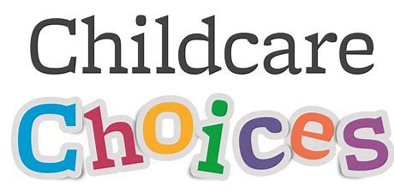 www.childcarechoices.gov.uk

Marcham Early Years Partnership
The Early Years Partnership was formed in September 2007 and unites the work of Marcham Pre-school and Marcham Primary School’s Reception Class. Whilst each remains under its own management, we work together with an aim to provide the best possible Early Years’ experience for children between the ages of 2 and 5…. From commencing pre-school right through until the end of their Reception year… and beyond. The Unit exists to enable continuity and a smooth transition between Pre-school and Primary School whilst working within the Early Years Foundation Stage Curriculum (EYFS). This is in place to facilitate the learning and development for children commencing Pre-school at 2, after which the children are encouraged to progress through the EYFS. Children are eligible to join a Reception Class in the September following their 4th Birthday, when the final year of the curriculum is taught.

Marcham Pre-school and Reception Class staff work closely together to meet the goals and interests of the children. We come together for activities, special events and some singing and story times. We have a large, shared, outside area, allowing the children of all ages to play and learn together. There is a grassed area, climbing equipment and garden, space where the children use tricycles, scooters and other large apparatus, and canopied areas outside each classroom where separate outdoor activities can be set out when necessary to support the individual needs of the two groups and particularly meet the different requirements of the EYFS (upto age 5) and the National Curriculum (for children in Year 1). We run regular sessions, where the children from pre-school and the Reception class can mix and share resources and play. This also provides an opportunity for Reception class staff to get to know the children as well as share expertise and ideas for supporting them in their learning and development.”

In the Summer of 2023, the Partnership commenced on an exciting project to transform the outdoor area and develop an Adventure Area for bikes, role play, mud kitchen and so much more! This has been a huge undertaking with financial support and grants from a range of Marcham Community Groups.

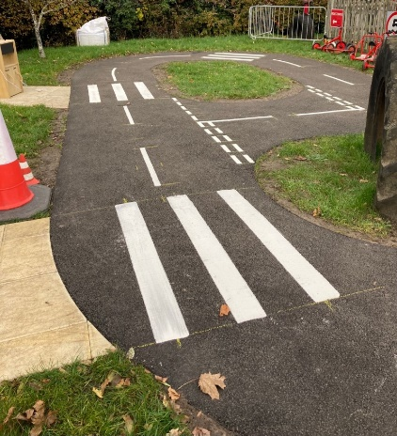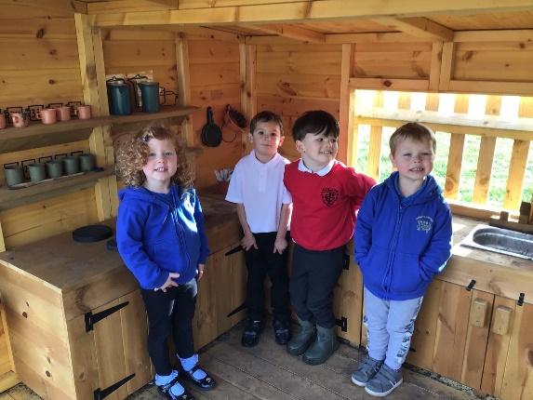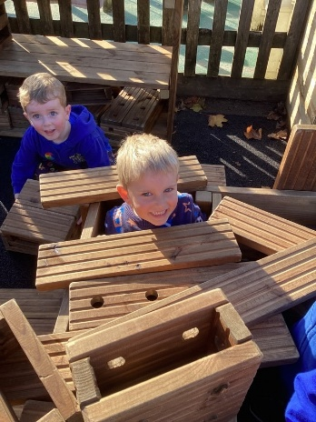

Policy Documents and Information
The Pre-school works in line with agreed policies and procedures in the following areas. These are reviewed and updated annually in line with statutory requirements, taking into account the views and wishes of the parents and management committee.

1.1 Children’s rights and entitlements |  | 3.2 First aid |  | 8.4 Risk assessment
1.2 Safeguarding children & child protection |  | 4.1 The role of the key person and settling-ion |  | 8.5 Fire safety and emergency evacuation
1.3 Looked after children |  | 5.1 Staffing |  | 8.6 No-smoking
1.4 Uncollected children |  | 6.1 Administering medicines |  | 9.1 Valuing diversity & promoting equality
1.5 Missing child |  | 6.2 Managing children who are sick, infection or with allergies |  | 9.2 British values
1.6 Use of mobile phones and cameras |  | 6.3 Nappy changing |  | 10.1 Admissions
1.7 Making a complaint |  | 6.4 Food and drink |  | 10.2 Confidentiality & client access to records
1.8 Recording & reporting of accidents & incidents |  | 6.5 Food hygiene |  | 10.3 Fees
2.1 Employment |  | 8.1 Health and safety general standards |  | 10.4 Information sharing
2.2 Student placements |  | 8.2 Maintaining children’s safety & security on premises |  | 10.5 Parental involvements
3.1 Induction of employees and volunteers |  | 8.3 Supervision of children on outings and visits |  | 10.6 Children’s records

If you would like to see our full policy documents at this time, please contact the Early Years Teacher. Please take the time to review any policies of particular interest including Policy 6.2

Summary of Current Sickness Policy
We expect all children attending pre-school to be in good health, rested and well enough to participate in all pre-school activities. If your child becomes unwell during the day, you will be required to collect them as soon as possible.

We operate the following main exclusions for illnesses and infections: -

- 24 hours following any temperature over 38⁰
- 48 hours following any symptoms/episodes of vomiting or diarrhoea
- 24 hours after beginning any course of antibiotics
- We do not accept children who have required Calpol or similar medications.

We take the health and well-being of the children and the staff seriously and operate high levels of hygiene practices and exclusions to ensure the continued health of everyone attending pre-school.

We ask that all absences are reported either by telephoning the setting or adding a note onto Tapestry before 9.30am of the first day of absence.

The Early Years Foundation Stage Framework
“At Marcham Pre-school we understand that all children are individual with differing needs and interests. We offer a range of activities throughout our sessions, encouraging the children to build on what they already know and further their understanding of the world around them. Children can choose which activities they would like to explore both indoors and outside. We provide a safe environment that minimises risks to children, but at the same time offer a structure in which they can learn to take their own risks. We have a quiet area where children can rest or sleep if they need to. We monitor each child regularly and record their progress in their development file, this can take place through daily discussions with the child about what they are doing or through more formal observations. This information is used by staff to plan areas where the child should progress over the next few weeks/months. Parents are regularly given the opportunity to review their child’s file and can ask to do so at any time. Staff are happy to discuss any concerns you may have.”

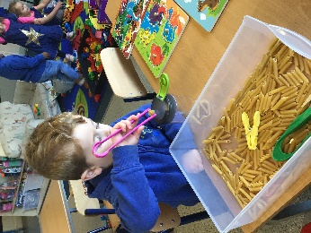 |  | Fine motor skills and hand-eye co-ordination are essential skills for building the foundations for emerging writing. We offer a range of activities to help children develop their hand and finger muscles.
Instilling a love of reading is essential for children’s literacy development | 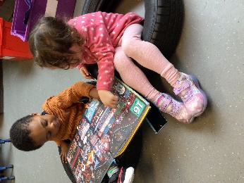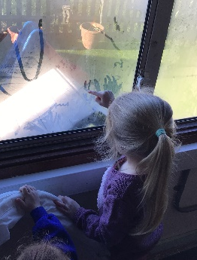 |  |  | Writing skills begin with mark-making which we promote via a range of media
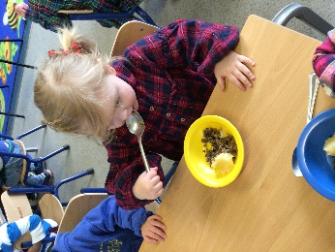 |  | 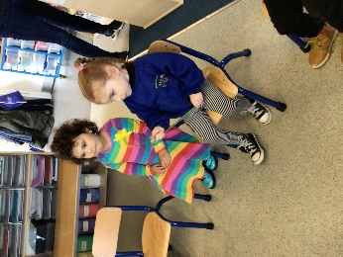 | 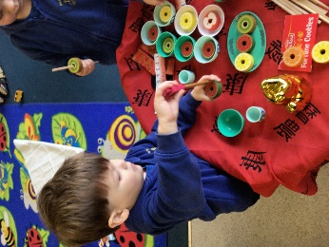
At Marcham pre-school, we explore different cultures, traditions and festivals, such as ….. Burn’s Night, St. David’s Day, Chinese New Year…
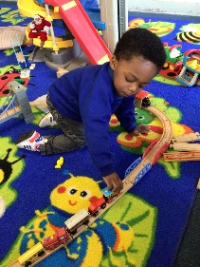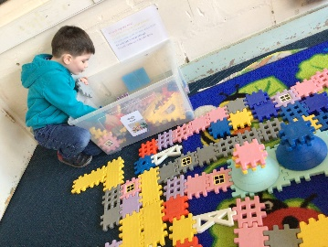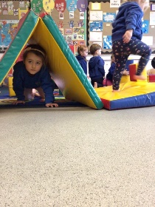
Children have a wide range of opportunities to explore, learn and develop new skills.

“Through our Key Person approach, we aim to provide young children with secure relationships as a firm foundation for them to gradually learn to become independent at their own pace. We understand the important role parents play in educating their children and welcome any input and involvement. Each child has a development file which we share and discuss with parents. We also ask for contributions from home, such as current interests, developmental achievements, etc.”

The staff role at Marcham pre-school is varied…. No two days are the same!!

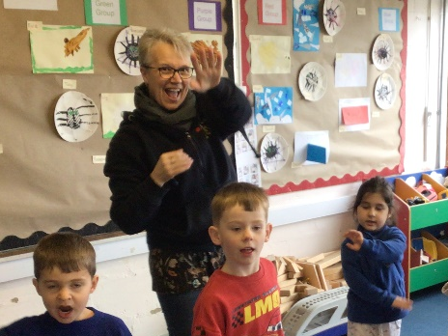 |  | 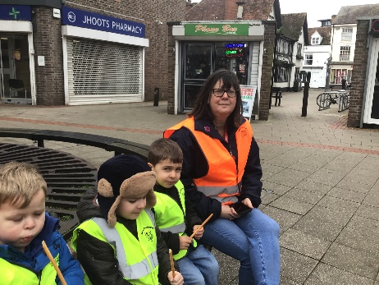
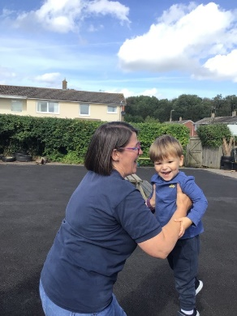 |  | 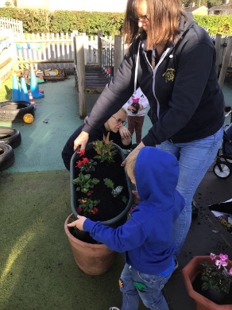
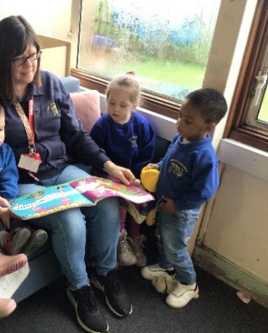 |  | 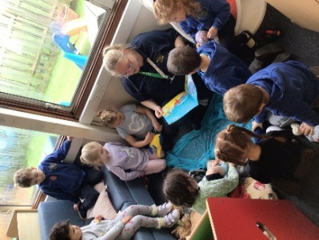
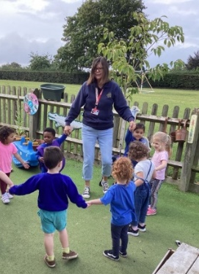 | 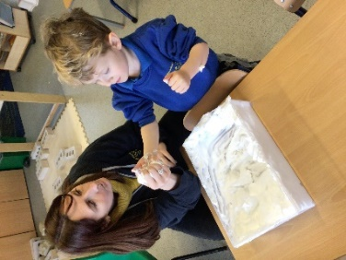 | 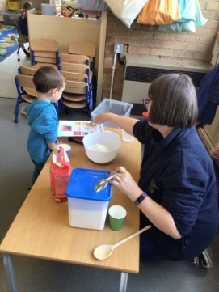
“All children are included in our cycle of observations as well as daily ‘snapshot’ records. This ensures that the learning needs of all children are met and helps plan suitable activities to support them. By creating a secure bond with the adults in the setting we can enhance the children’s learning through questioning and by encouraging their own explorations. Many activities allow the child to learn through their personal discoveries rather than being ‘taught’.”

How do we ensure each child makes progress and develops appropriate skills?
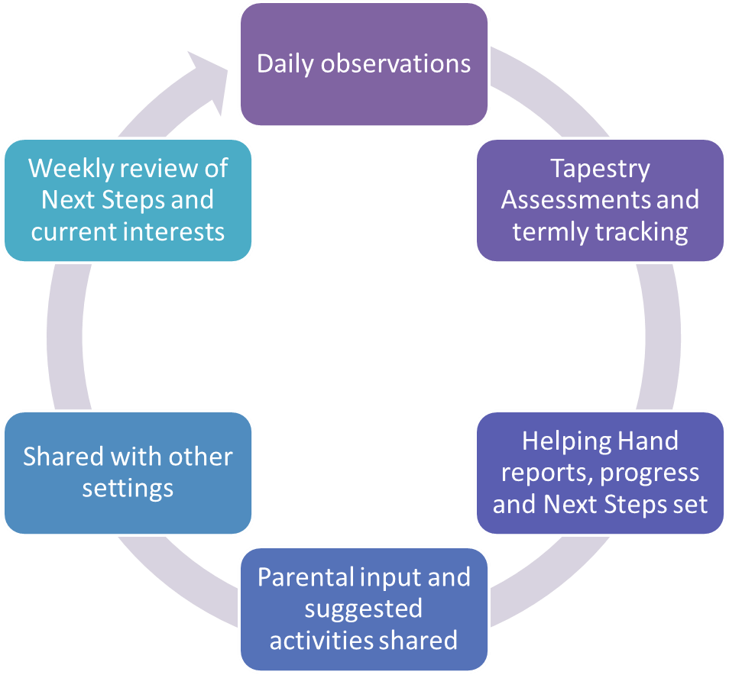

We work within two distinct groups to enable the curriculum to be adapted to meet the appropriate ages and developmental stages of the children. Our cohorts are identified as follows: -
Cubs  These children will be under 4 on 31st August. (i.e., will have 2 or more years at Pre-school before starting in a school Reception class) | Bears  These children will be 4 by 31st August. (i.e., In their final year of pre-school before starting in a school Reception class)

LEARNING AND DEVELOPMENT
“Children develop and learn in different ways and at different rates, and all areas of learning and development are equally important and inter-connected.”

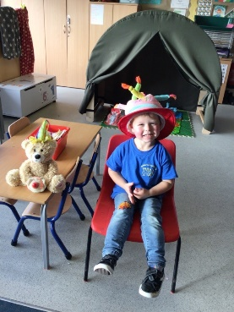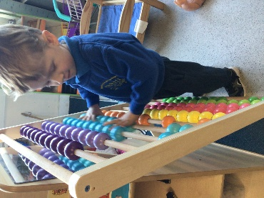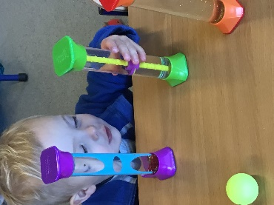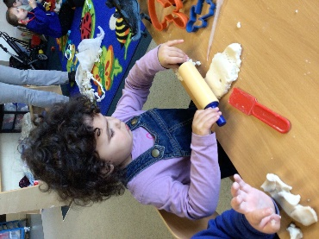
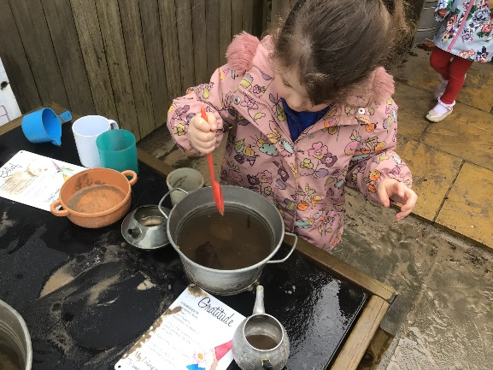
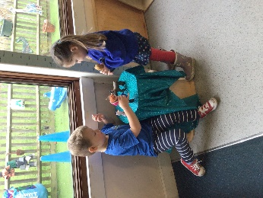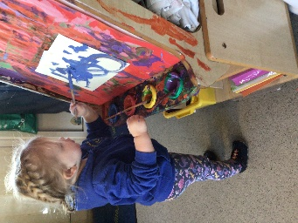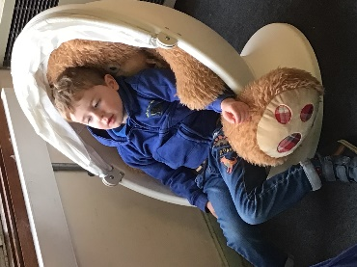
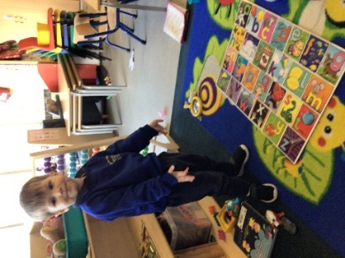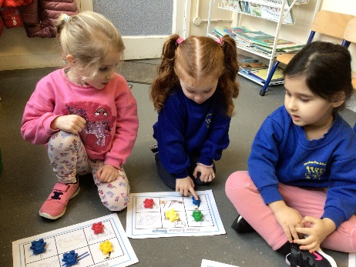

PRIME AREAS OF DEVELOPMENT

Personal, social, emotional development
Children are encouraged to play in groups of different sizes on a wide range of tasks so as to develop their social skills. These include sharing, turn taking (e.g., board games), expressing themselves (puppets and drama), trusting new grown-ups (i.e., staff and parent helpers) and other children as well as learning to become more independent. During our sessions we have set times for group discussions and children are expected to listen carefully and show respect for the feelings of others.

Communication and language
We have a book corner which is arranged with comfortable seating, where the children are able to select a book for themselves or ask to share it with an adult or with friends. Each Pre-school session includes singing, rhymes or ring games and are rounded off with story time. The staff work to extend the children’s vocabulary and use language in all activities, especially through role play.

Physical Development
Fine and gross motor skills are constantly practiced during sessions. The former through activities such as colouring, pouring in the sand and water tray, painting, writing, threading, kneading, cutting and gluing, etc. The latter through using equipment to throw, catch, peddle, balance, hop and jump. We have a large outside play area where the children can ride tricycles and play games.

SPECIFIC AREAS OF DEVELOPMENT

Mathematics
At Pre-school we tackle mathematics very practically. We use sand and water trays, playdo, cooking and construction kits to develop the children’s sense of spatial awareness and measurement, including capacity and volume. Through a range of games and apparatus children are introduced to the number system and the language involved in simple operations such as addition/subtraction, sorting/sequencing (eg. Dominoes and threading beads). We use many opportunities for counting/matching throughout each session. A variety of activities to allow the exploration of patterns also encourage the children to think about the repetition in number patterns.

Understanding the World
Children are encouraged to think about and discuss their environment, explore materials, and observe the living world. Visitors (eg. The Police and Fire Brigade) help to extend these experiences as well as visits to amenities within the local environment. We have developed a working garden and nature area where we grow vegetables, fruits, sensory plants, as well as stinging nettles to attract the butterflies and caterpillars! We also have a bird table.

Expressive arts and design
Opportunities for music making, singing, imaginative play, dance and art and craft activities are provided, both indoors and outside, to allow the children to explore their senses and express their feelings freely. Some of these activities may be taped and work is displayed around the room to help the children develop a sense of pride and ownership in their surroundings.

Literacy
We focus on the children’s developing listening skills and in being able to distinguish between sounds and noises around them as well as using a selection of word games and alphabet puzzles to promote both visual and audio discrimination. The children are encouraged to develop their writing skills, starting with swirls and ‘scribbles’ and eventually moving onto ‘pretend’ writing and emerging recognisable letters. We support the children in their development of hand-eye co-ordination skills, pencil control, as well as fine (finger) and gross (whole body) motor skills. By providing a language rich environment the children learn that speaking, reading and writing are a normal part of our lives and soon wish to engage with these activities. A tray of writing materials (including pens, pencils, notepaper and booklets) is always available to extend their opportunities for writing in role-play situations.

WHY WE ‘DO’ WHAT WE ‘DO’ AT PRE-SCHOOL……
Because children retain
10% of what they read…
20% of what they hear….
30% of what they see….
50% of what they see and hear

90% of what they experience ‘first-hand’

LEARNING THROUGH PLAY

We hope this prospectus has given you an insight into what Marcham Pre-school provides for young children and their families, and what it is like for the children who attend our sessions. If there is anything else you would like to know, or if you would like to arrange a visit, please telephone us 01865 392101.

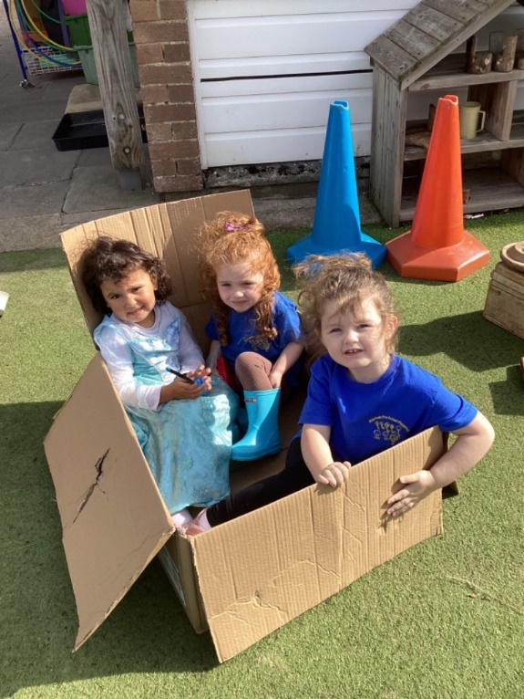

Frequently Asked Questions

Does my child need to be potty trained before starting at pre-school? No…. we accept children in nappies and will support you and your child once the time is right to transition to using a potty or toilet. Parents should provide their own supply of nappies and wipes however we ask you to dispose of soiled/wet nappies at home and we use washable nappy bags to transport used nappies and ask you to launder and return these bags as soon as you can.

What are the arrangements for snack and lunchtime? We ask parents to provide a healthy snack for mid-morning, this can be a whole piece of fruit, which we will cut up if necessary. At lunchtime, the children will enjoy a packed lunch provided from home. We are unable to heat food or serve food which is heated (for example in a thermos flask). We also recommend including an ice pack, as we are not able to keep foods in the refrigerator.

Do you provide ‘wrap around’ care? Unfortunately, not. Our sessions run from 8.45am until 3.00pm (or 12pm/1pm if booking a morning or morning/lunch session)

I’m worried about leaving my child, will they cope? We understand that it can be scary leaving your child with people you don’t know, particularly if this is the first time, they have been away from you. We have a comprehensive transition plan and will offer regular ‘stay and play’ sessions, home visits, open evenings and welcome pack all aimed at helping you and your child to become familiar with the classroom and the staff well before their start date. During a child’s first few days we will remain in regular contact with you via Tapestry, or with phone calls to reassure you on how your child is settling. We may suggest an earlier finishing time if a full day appears to be too overwhelming.

What if my child requires a nap? We have a cosy area which transforms into a sleeping space. Children who nap regularly are given their own sleep bag with sheet and blanket which are laundered weekly. We have foam sleep mats for comfort and staff monitor sleeping children regularly. We find that children are able to sleep well within the classroom and the children who are not sleeping soon recognise the need to play elsewhere and do not disturb those resting.

Do you teach phonics and writing skills? Within Early Years, the focus is very much on developing the aural (hearing) and visual (sight) discrimination skills (being able to hear or see the difference between sounds or shapes). We provide a range of activities to support phonological awareness and help children to hear the sounds in words. We also provide access to lots of resources to strengthen the shoulders/hands and finger muscles which will be needed for effective pencil control. We have constant access to mark-making materials to allow children to practice these skills once they feel able and interested in doing so.

How will I know how my child is progressing? Each week we select one from child each Key Group to be ‘Helping Hand’, as well as being an important role for the child (when they are asked to help the adults with tasks such as sweeping the floor, or setting out the chairs), this provides staff with an opportunity to discuss each child’s progress with parents regularly. Staff will also provide a brief handover at the end of each session and tell you about any important events from the day. You are welcome to ask to speak to your Key Person at any time.

Do children have to wear a uniform? While we do offer a delightful range of uniform items, these are not compulsory. Many children do enjoy the routine of wearing pre-school tops (t-shirt, polo, sweatshirt, fleece, hoodie) you might prefer to wear general clothing, but we ask that this is everyday wear that is practical and easy to wash. We have aprons, wellies and waterproofs for the children to wear to protect their clothing, however we do not insist that they are worn if a child is particularly reluctant – please bear this in mind when dressing your child for pre-school sessions.

When do I have to pay my fees? Invoices are raised on the 22nd of each month and we ask for payment within 30 days. Invoices can be calculated on an ‘actuals’ basis (so some months are higher than others depending on when the holidays fall) or can be ‘annualised’ (an equal payment made each month based on 1/12 of your annual fees).

Please use this space to add any other questions you might have. We welcome your enquiries and will try to include them in future editions of our Prospectus to help future families.

Name:
E: mail:
Telephone number:

Please return to Marcham Pre-school, Morland Road, Marcham, Oxon, OX13 6PY, or by scanning/photographing and sending to:
marcham-preschool@hotmail.co.uk

